Notable moth records, May-July 2018

Since April there have been some excellent moths recorded on the Island including three new species for VC10.

Double Line (Mythimna turca) is a Nationally scarce B species, meaning that it occurs in 31 to 100 10km squares in Great Britain. One was taken at light in Totland.

On 23 May, lepidopterists visiting Mottistone Down found larvae of Scythris crassiuscula on Common Rock-rose (Helianthemum nummularium). Some larvae were collected and bred through to confirm the species, which is also Nationally scarce B.

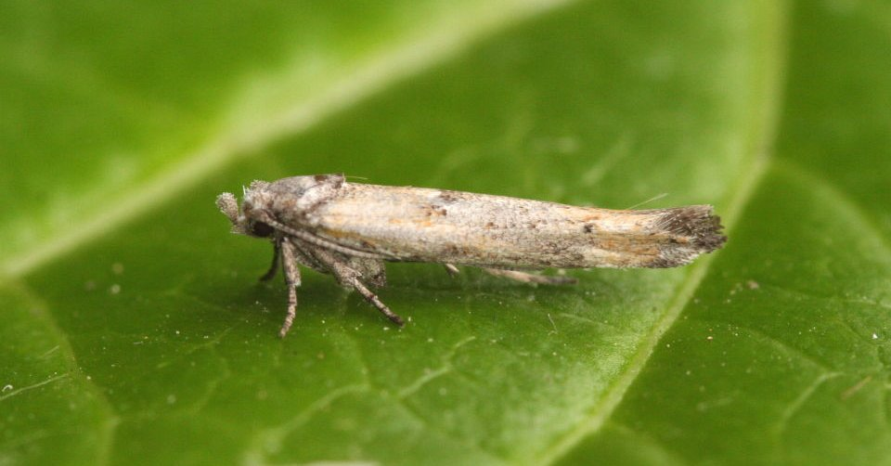
Zelleria oleastrella is a rare but increasingly recorded migrant moth from southern Europe. Two were recorded from Hampshire in 2016 but the first for the Island came to MV light in Shanklin on 18 June. The larvae mine the leaves of Olive trees.
Zelleria oleastrella – Shanklin

The good weather has seen a decent run of migrant moths reported with a Druid (Aedia funesta) trapped in Totland on 01 July. There are only 12 previous UK records of this species, two of which were from the same site in Totland. A Light Crimson Underwing (Catocala promissa) was recorded at St. Catherine’s Point on 04 July and a Dark Crimson Underwing (Catocala sponsa) at Bonchurch on 07 July. Other good migrant moths have included Splendid Brocade (Lacanobia splendens) and four Catoptria verellus, all from Shanklin.

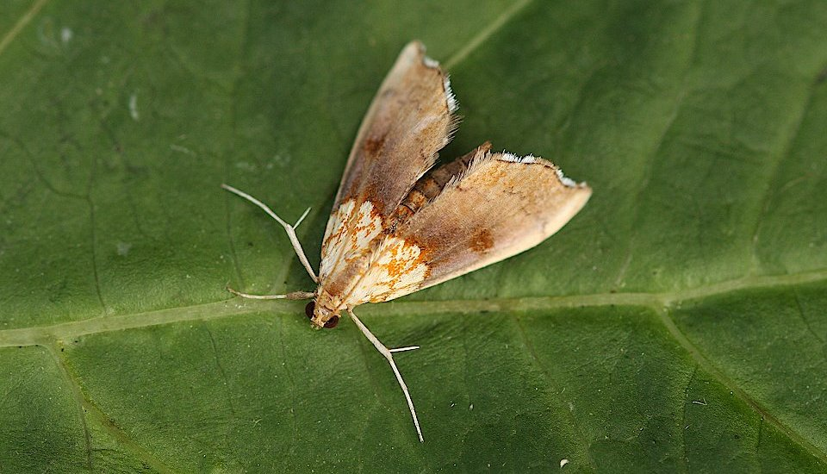
Another presumed migrant is Agrotera nemoralis which was first recorded on the Island in 2015 at Borthwood Copse and with five records up to the end of 2017. There have been a further five records in 2018. The first was seen at Ventnor Botanic Gardens on 30 May, two have been trapped in Bonchurch and three in Shanklin with a single on 09 June and two on 08 July.
Agrotera nemoralis – Shanklin

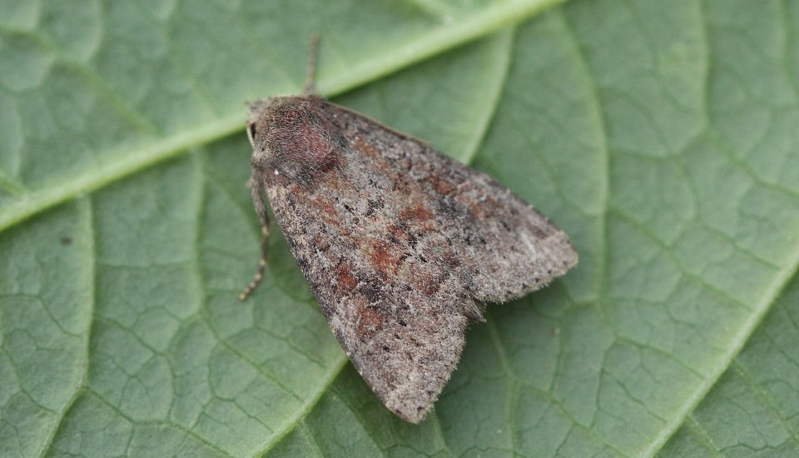
The non-migrant highlight was undoubtedly finding four Suspected (Parastichtis suspecta) at St. Catherine’s Point on 04 July. There are only two previous county records, from July 1897 and August 1963. It is hoped that there is a viable population in that area. The larvae feed on Birch and Sallow.
Suspected (Parastichtis suspecta) – St. Catherine’s Point
Of course there have been many other interesting finds including Scythris picaepennis and Epermenia insecurella on Mottistone Down, the latter not seen here since 1926. Seven Endothenia nigricostana were recorded in Shanklin. This is an unobtrusive moth that is associated with the larval food plant Hedge Woundwort (Stachys sylvatica). It is probably widespread but there are just four previous records.

There have also been records of Boxworm (Cydia perspectalis) from Totland, Cowes and Shanklin; this potential pest species is clearly increasing on the Island.

Update:

The run of rare migrant moths has continued. A Dewick’s Plusia (Macdunnoughia confusa) was recorded in Bonchurch on 13 July and trapping at Niton on 20 July produced the first Dotted Footman (Pelosia muscerda) and second Dusky Hook-tip (Drepana curvatula) for the Island. Over in Shanklin, Psammotis pulveralis was recorded on the same night. The following evening saw a stunning male Beautiful Marbled (Eublemma purpurina) trapped at Wheelers Bay, another new species for IW. Incredibly, a female Beautiful Marbled was trapped in Bonchurch and another Dusky Hook-tip was trapped in Shanklin on 22 July. Finally, a Light Crimson Underwing (Catocala promissa) was trapped in Shanklin on 30 July.

Iain Outlaw
31 July 2018

